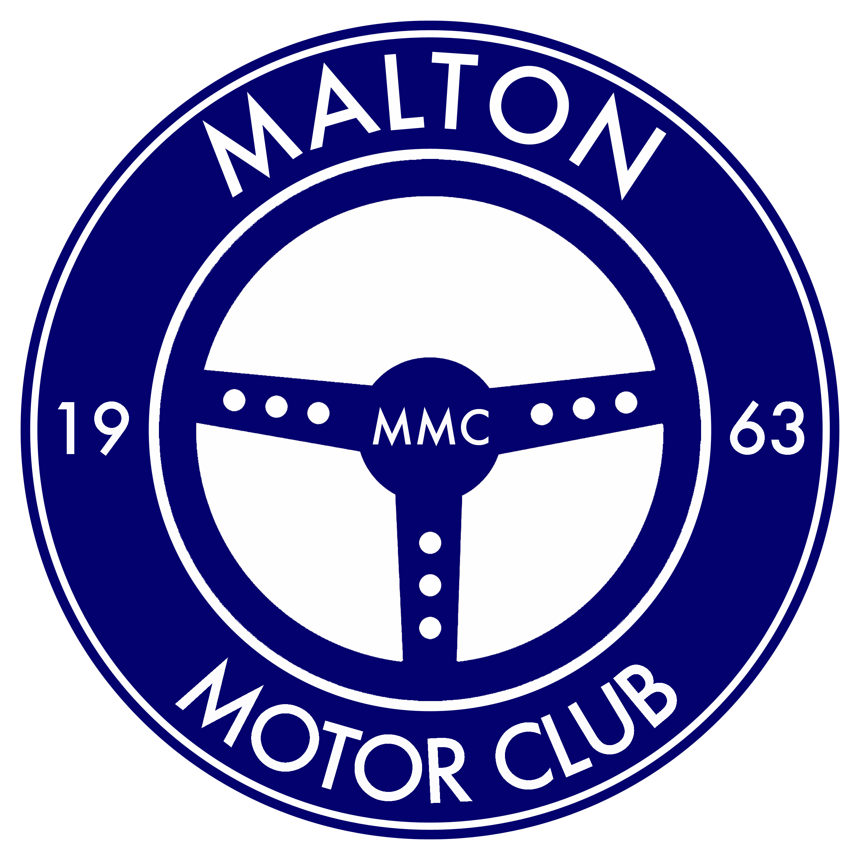

To Whom It May Concern;

I can confirm these persons are Officials co-ordinating a Road Navigational Event.

The event has been organised by Malton Motor Club, and has the approval of this areas Route Liaison Officer, Mr John Richardson, on behalf of our National governing body, The Motor Sport Association of the United Kingdom (M.S.A).

All the cars are insured, are road legal as defined by the Road Traffic Act 1988, and in accordance with the 2017 rules specified by the M.S.A.

We apologise if the event has caused you any inconvenience, and if you have questions please do not hesitate to contact me, but in the meantime, I would request that you kindly allow the two occupants in this car to continue unimpeded.

On behalf of Malton Motor Club,

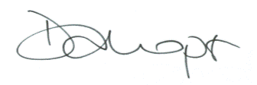

Donna Harper, Club Secretary
07711 094 309

